**Customer Purchase Analytics for E-commerce Platform**

**Data Analytics Tasks:**

**A. Basic Aggregation:**

**A. Basic Aggregation**

**Findings:**

* Simple aggregations like SUM, AVG, COUNT, etc., can be used to understand the overall performance of the business.
* These metrics are useful for quickly summarizing data such as total sales or the number of products sold.

**Insights:**

* Aggregated data provides a high-level view of business performance and can identify broad trends.

**Recommendations:**

* Use basic aggregation as the starting point for analysis, especially when trying to get an overview of sales or performance metrics.
* Combine aggregation with other techniques to uncover deeper insights.

**Visualization:**

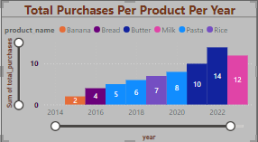

**1A Total number of purchases per product per year**

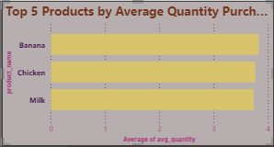

**1B: Top-selling products each year**

**SQL Query:**

**1A : Total number of purchases per product per year**

SELECT

product_id,

YEAR(purchase_date) AS year,

COUNT(*) AS total_purchases

FROM

purchase_history

GROUP BY

product_id, YEAR(purchase_date);

**1B: Top-selling products each year**

WITH ProductSales AS (

SELECT

product_id,

YEAR(purchase_date) AS year,

COUNT(*) AS total_purchases

FROM

purchase_history

GROUP BY

product_id, YEAR(purchase_date)

),

TopSellingProducts AS (

SELECT

product_id,

year,

total_purchases,

ROW_NUMBER() OVER (PARTITION BY year ORDER BY total_purchases DESC) AS row_num

FROM

ProductSales

)

SELECT

tsp.year,

p.product_name,

tsp.total_purchases

FROM

TopSellingProducts tsp

JOIN

products p ON tsp.product_id = p.product_id

WHERE

tsp.row_num = 1 order by tsp.year ASC ;

**B. Join Operations:**

**B. Join Operations**

**Findings:**

* Joins between tables like customers, orders, and products allow us to combine data from different sources.
* Inner, left, and right joins offer flexibility in merging datasets based on the business requirements.

**Insights:**

* Join operations enable a more detailed analysis by linking different business aspects such as customer and product data.

**Recommendations:**

* Use join operations to connect related datasets and gain a comprehensive understanding of customer behavior and sales trends.
* Be cautious with join types to avoid data duplication or loss of critical information.

**Visualization:**

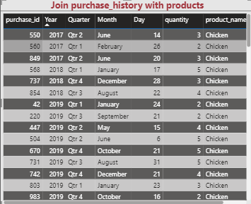 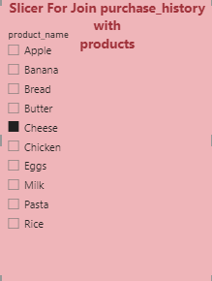

**2A - Average quantity purchased per product**

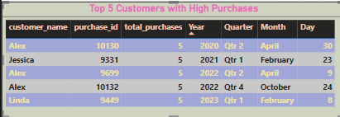

**2B2 – Top 5 Customers with high purchase**

**SQL Query:**

**2A - Average quantity purchased per product**

SELECT

ph.product_id,

p.product_name,

AVG(ph.quantity) AS avg_quantity

FROM

purchase_history ph

JOIN

products p ON ph.product_id = p.product_id

GROUP BY

ph.product_id, p.product_name;

-- Top 5 products by average quantity purchased

WITH AvgQuantity AS (

SELECT

ph.product_id,

p.product_name,

AVG(ph.quantity) AS avg_quantity

FROM

purchase_history ph

JOIN

products p ON ph.product_id = p.product_id

GROUP BY

ph.product_id, p.product_name

)

SELECT

product_name,

avg_quantity

FROM

AvgQuantity

ORDER BY

avg_quantity DESC

LIMIT 5;

**2B1:**

SELECT

ph.purchase_id,

ph.product_id,

p.product_name,

ph.purchase_date,

ph.quantity

FROM

purchase_history ph

JOIN

products p

ON

ph.product_id = p.product_id;

**2B2:**

SELECT

ph.purchase_id,

ph.customer_id,

cp.first_name AS customer_name,

cp.email AS customer_email,

ph.purchase_date,

SUM(ph.quantity) AS total_purchases

FROM

purchase_history ph

JOIN

customer_profile cp

ON

ph.customer_id = cp.customer_id

GROUP BY

ph.customer_id, cp.first_name, cp.email, ph.purchase_id, ph.purchase_date

ORDER BY

total_purchases DESC

LIMIT 5;

**C. Window Functions:**

**C. Window Functions**

**Findings:**

* Window functions like RANK(), ROW_NUMBER(), and LEAD() help analyze trends over a partition of data.
* They allow comparison across different subsets without grouping.

**Insights:**

* Window functions are valuable for trend analysis, ranking products or customers, and identifying outliers.

**Recommendations:**

* Apply window functions when tracking trends or ranking performance metrics, like top customers or popular products, over time.

**Visualization:**

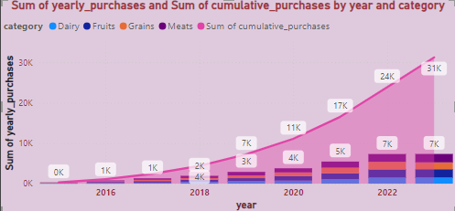

**SQL Query:**

SELECT

p.category,

YEAR(ph.purchase_date) AS year,

SUM(ph.quantity) AS yearly_purchases,

SUM(SUM(ph.quantity)) OVER (

PARTITION BY p.category

ORDER BY YEAR(ph.purchase_date)

) AS cumulative_purchases

FROM

purchase_history ph

JOIN

products p

ON

ph.product_id = p.product_id

GROUP BY

p.category,

YEAR(ph.purchase_date)

ORDER BY

p.category,

year ASC;

**D. Rank and Dense Rank**

**Findings:**

* Rank and Dense Rank functions are useful for ordering data based on specific metrics, like sales or customer purchases.

**Insights:**

* These functions help in identifying high performers and segmenting them for further analysis.

**Recommendations:**

* Use RANK() for distinguishing between top-performing entities and DENSE_RANK() for continuous ranking without gaps.

**Visualization:**

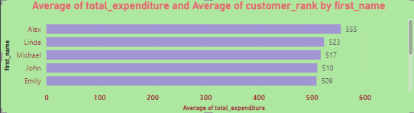

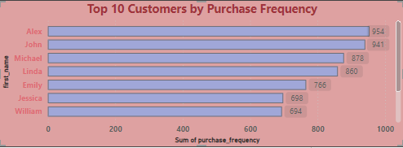

**SQL Query:**

SELECT

customer_id,

first_name,

purchase_frequency,

frequency_rank

FROM (

SELECT

cp.customer_id,

cp.first_name,

COUNT(ph.purchase_id) AS purchase_frequency,

DENSE_RANK() OVER (ORDER BY COUNT(ph.purchase_id) DESC) AS frequency_rank

FROM

purchase_history ph

JOIN

customer_profile cp ON ph.customer_id = cp.customer_id

GROUP BY

cp.customer_id, cp.first_name

) ranked_customers

WHERE

frequency_rank <= 10

ORDER BY

frequency_rank;

**E. Percentiles**

**Findings:**

* Percentiles allow you to understand how values are distributed within a dataset, such as identifying the top 10% of customers based on spending.

**Insights:**

* Percentiles provide a powerful tool for segmentation and targeting high-value customers.

**Recommendations:**

* Use percentiles to develop targeted marketing strategies by identifying high-value customers or underperforming segments.

**Visualization:**

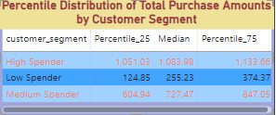

**SQL Query:**

WITH CustomerPurchases AS (

SELECT

cp.customer_id,

SUM(ph.quantity * p.price_per_unit) AS total_purchase_amount

FROM

purchase_history ph

JOIN

products p ON ph.product_id = p.product_id

JOIN

customer_profile cp ON ph.customer_id = cp.customer_id

GROUP BY

cp.customer_id

),

SegmentedCustomers AS (

SELECT

customer_id,

total_purchase_amount,

CASE

WHEN total_purchase_amount >= 1000 THEN 'High Spender'

WHEN total_purchase_amount BETWEEN 500 AND 999 THEN 'Medium Spender'

ELSE 'Low Spender'

END AS customer_segment

FROM

CustomerPurchases

),

PercentileRanks AS (

SELECT

customer_segment,

total_purchase_amount,

PERCENT_RANK() OVER (PARTITION BY customer_segment ORDER BY total_purchase_amount) AS percentile_rank

FROM

SegmentedCustomers

)

SELECT

customer_segment,

MAX(CASE WHEN percentile_rank <= 0.25 THEN total_purchase_amount END) AS Percentile_25,

MAX(CASE WHEN percentile_rank <= 0.50 THEN total_purchase_amount END) AS Median,

MAX(CASE WHEN percentile_rank <= 0.75 THEN total_purchase_amount END) AS Percentile_75

FROM

PercentileRanks

GROUP BY

customer_segment;

**F. Median Calculation**

**Findings:**

* The median provides a better measure of central tendency in skewed datasets, as it is less affected by outliers compared to the mean.

**Insights:**

* The median helps when assessing customer spending habits or product prices that vary widely.

**Recommendations:**

* Use the median to assess the "typical" value in datasets with extreme variations (e.g., salaries, sales prices).

**Visualization:**

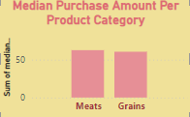

**SQL Query:**

WITH RankedPurchases AS (

SELECT

p.category,

pu.total_amount,

ROW_NUMBER() OVER (PARTITION BY p.category ORDER BY pu.total_amount) AS RowAsc,

ROW_NUMBER() OVER (PARTITION BY p.category ORDER BY pu.total_amount DESC) AS RowDesc

FROM purchases pu

JOIN products p ON pu.product_id = p.product_id

JOIN customer_profile cp ON pu.customer_id = cp.customer_id

WHERE p.category IN ('grains', 'meats', 'fruits','Dairy') -- Filter for specific categories

)

SELECT

category,

AVG(total_amount) AS median_purchase_amount

FROM RankedPurchases

WHERE RowAsc = RowDesc

GROUP BY category;

**G. Complex Aggregation**

**Findings:**

* Complex aggregations involve grouping data and applying advanced aggregate functions (like SUM, AVG, COUNT) with specific conditions.

**Insights:**

* Complex aggregation allows deeper analysis, such as revenue per customer or product category.

**Recommendations:**

* Use complex aggregations to break down performance by categories or time periods, especially when analyzing trends or revenue.

**Visualization:**

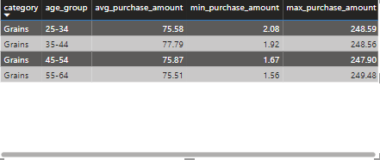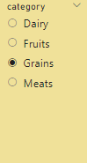

**SQL Query:**

WITH CustomerAgeGroup AS (

SELECT

customer_id,

CASE

WHEN TIMESTAMPDIFF(YEAR, c.date_of_birth, CURDATE()) BETWEEN 18 AND 24 THEN '18-24'

WHEN TIMESTAMPDIFF(YEAR, c.date_of_birth, CURDATE()) BETWEEN 25 AND 34 THEN '25-34'

WHEN TIMESTAMPDIFF(YEAR, c.date_of_birth, CURDATE()) BETWEEN 35 AND 44 THEN '35-44'

WHEN TIMESTAMPDIFF(YEAR, c.date_of_birth, CURDATE()) BETWEEN 45 AND 54 THEN '45-54'

WHEN TIMESTAMPDIFF(YEAR, c.date_of_birth, CURDATE()) BETWEEN 55 AND 64 THEN '55-64'

WHEN TIMESTAMPDIFF(YEAR, c.date_of_birth, CURDATE()) >= 65 THEN '65+'

ELSE 'Unknown'

END AS age_group

FROM customer_profile c

)

SELECT

p.category,

ag.age_group,

AVG(pu.total_amount) AS avg_purchase_amount,

MAX(pu.total_amount) AS max_purchase_amount,

MIN(pu.total_amount) AS min_purchase_amount

FROM purchases pu

JOIN products p ON pu.product_id = p.product_id

JOIN CustomerAgeGroup ag ON pu.customer_id = ag.customer_id

GROUP BY

p.category,

ag.age_group

ORDER BY

p.category, ag.age_group;

**H. Grouping**

**Findings:**

* Grouping is essential for segmenting data by different categories, like product type, region, or customer demographics.

**Insights:**

* Grouping enables the comparison of different segments and provides insights into which categories are performing best.

**Recommendations:**

* Use grouping to categorize sales data, customer demographics, or product performance to generate targeted insights.

**Visualization:**

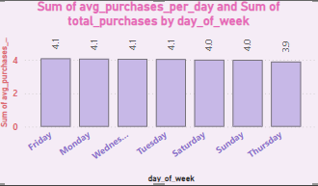

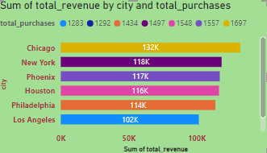

**SQL Query:**

**H1Grouping**

SELECT

DAYNAME(STR_TO_DATE(p.purchase_date, '%Y-%m-%d')) AS day_of_week,

COUNT(*) AS total_purchases,

COUNT(*) / COUNT(DISTINCT STR_TO_DATE(p.purchase_date, '%Y-%m-%d')) AS avg_purchases_per_day

FROM

purchases p

GROUP BY

day_of_week

ORDER BY

FIELD(day_of_week, 'Monday', 'Tuesday', 'Wednesday', 'Thursday', 'Friday', 'Saturday', 'Sunday');

**H2Grouping:**

SELECT

c.city,

COUNT(p.purchase_id) AS total_purchases,

SUM(p.total_amount) AS total_revenue

FROM

customer_profile c

JOIN

purchases p ON c.customer_id = p.customer_id

GROUP BY

c.city

ORDER BY

total_revenue DESC**;**

**I. Case Statement**

**Findings:**

* The CASE statement allows conditional logic in SQL queries to categorize data or calculate values based on specific conditions.

**Insights:**

* This helps in creating custom classifications or handling missing data more effectively.

**Recommendations:**

* Implement the CASE statement to apply custom rules, such as classifying products based on price or determining customer segments based on spending.

**Visualization:**

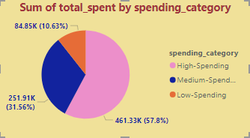

**SQL Query:**

WITH CustomerSpending AS (

SELECT

c.customer_id,

SUM(p.total_amount) AS total_spent

FROM

customer_profile c

JOIN

purchases p ON c.customer_id = p.customer_id

GROUP BY

c.customer_id

),

RankedSpending AS (

SELECT

customer_id,

total_spent,

PERCENT_RANK() OVER (ORDER BY total_spent) AS percentile_rank

FROM

CustomerSpending

)

SELECT

customer_id,

total_spent,

CASE

WHEN percentile_rank <= 0.33 THEN 'Low-Spending'

WHEN percentile_rank > 0.33 AND percentile_rank <= 0.66 THEN 'Medium-Spending'

ELSE 'High-Spending'

END AS spending_category

FROM

RankedSpending

ORDER BY

total_spent DESC;

**J. Join with Condition**

**Findings:**

* Conditional joins are used to combine datasets based on specific criteria, offering flexibility in how data is merged.

**Insights:**

* This is useful when you need to combine data based on particular conditions like customer behavior or order thresholds.

**Recommendations:**

* Use conditional joins to merge data on specific business rules, like combining customer data with purchase history for targeted insights.

**Visualization:**

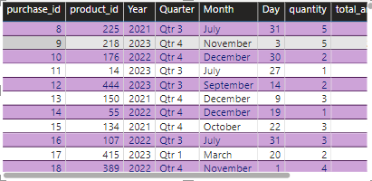

**SQL Query:**

WITH CustomerWithAge AS (

SELECT

customer_id,

DATE_FORMAT(FROM_DAYS(DATEDIFF(CURDATE(), STR_TO_DATE(date_of_birth, '%Y-%m-%d'))), '%Y') + 0 AS age

FROM

customer_profile

)

SELECT

p.purchase_id,

p.customer_id,

p.product_id,

p.purchase_date,

p.quantity,

p.total_amount

FROM

purchases p

JOIN

CustomerWithAge cwa ON p.customer_id = cwa.customer_id

WHERE

cwa.age > 30;

**K. Top N Analysis**

**Findings:**

* The Top N Analysis allows you to focus on top products, customers, or regions based on a given metric (e.g., total sales, number of purchases).

**Insights:**

* Identifying top N customers/products helps prioritize business decisions, like inventory management or customer retention.

**Recommendations:**

* Use Top N Analysis for decision-making in areas such as marketing, sales campaigns, and product prioritization.

**Visualization:**

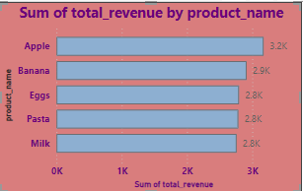

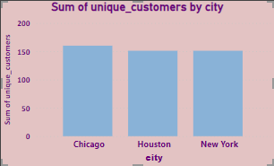

**SQL Query:**

**K1. Top N Analysis:**

SELECT

pr.product_name,

p.product_id,

SUM(p.total_amount) AS total_revenue

FROM

purchases p

JOIN

products pr ON p.product_id = pr.product_id

GROUP BY

p.product_id, pr.product_name

ORDER BY

total_revenue DESC

LIMIT 5;

**K2. Top N Analysis:**

SELECT

c.city,

COUNT(DISTINCT c.customer_id) AS unique_customers

FROM

customer_profile c

JOIN

purchases p ON c.customer_id = p.customer_id

GROUP BY

c.city

ORDER BY

unique_customers DESC

LIMIT 3;

**L. Window Functions for Trend Analysis**

**Findings:**

* Window functions like LEAD(), LAG(), and CUME_DIST() can help analyze trends in data across partitions or over time.

**Insights:**

* Window functions enable a deeper understanding of data trends and help with forecasting future performance.

**Recommendations:**

* Apply window functions for predictive analytics, trend analysis, and understanding customer or product lifecycle patterns.

**Visualization:**

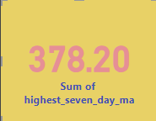

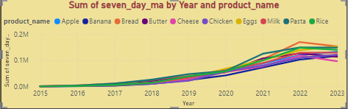

**SQL Query:**

**L. Window Functions for Trend Analysis:**

SELECT

p.product_id,

pr.product_name,

p.purchase_date,

p.customer_id,

SUM(p.total_amount) OVER (

PARTITION BY p.product_id

ORDER BY p.purchase_date

ROWS BETWEEN 6 PRECEDING AND CURRENT ROW

) AS seven_day_ma

FROM

purchases p

JOIN

products pr ON p.product_id = pr.product_id

ORDER BY

p.product_id, p.purchase_date;

WITH SevenDayMA AS (

SELECT

p.product_id,

pr.product_name,

p.purchase_date,

p.customer_id,

SUM(p.total_amount) OVER (

PARTITION BY p.product_id, p.customer_id

ORDER BY p.purchase_date

ROWS BETWEEN 6 PRECEDING AND CURRENT ROW

) AS seven_day_ma

FROM

purchases p

JOIN

products pr ON p.product_id = pr.product_id

)

SELECT

customer_id,

MAX(seven_day_ma) AS highest_seven_day_ma

FROM

SevenDayMA

GROUP BY

customer_id

ORDER BY

highest_seven_day_ma DESC

LIMIT 1;

**M. Nested Queries**

**Findings:**

* Nested queries or subqueries allow complex data analysis by embedding one query inside another.

**Insights:**

* This is valuable for filtering data based on aggregate values or conditions that require multi-level analysis.

**Recommendations:**

* Use nested queries when dealing with complex conditions that need to be broken down into substeps.

**SQL Query:**

**N. Date Analysis**

**Findings:**

* Date analysis allows for aggregating and grouping data based on dates, such as sales per month or customer acquisition trends over time.

**Insights:**

* Date analysis helps businesses track seasonal trends, sales cycles, and growth patterns.

**Recommendations:**

* Use date functions for time-based analysis, like identifying peak sales months or analyzing customer behavior by date.

**Visualization:**

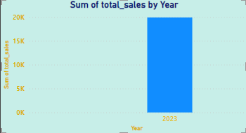

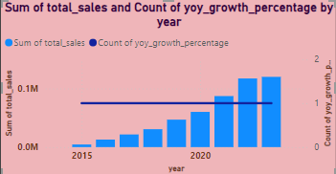

**SQL Query:**

**N1. Date Analysis:**

SELECT

DATE_FORMAT(STR_TO_DATE(purchase_date, '%Y-%m-%d'), '%Y-%m') AS sales_month,

SUM(total_amount) AS total_sales

FROM

purchases

GROUP BY

sales_month

ORDER BY

total_sales DESC

LIMIT 1;

**N2. Date Analysis:**

WITH yearly_sales AS (

SELECT

EXTRACT(YEAR FROM pu.purchase_date) AS year, -- Use the correct column for the purchase date

SUM(pr.price_per_unit * pu.quantity) AS total_sales

FROM

purchases pu -- Alias for the purchases table

JOIN

products pr ON pu.product_id = pr.product_id

GROUP BY

EXTRACT(YEAR FROM pu.purchase_date) -- Ensure the correct table alias and column

)

SELECT

year,

total_sales,

LAG(total_sales) OVER (ORDER BY year) AS previous_year_sales,

CASE

WHEN LAG(total_sales) OVER (ORDER BY year) IS NOT NULL THEN

(total_sales - LAG(total_sales) OVER (ORDER BY year))

/ LAG(total_sales) OVER (ORDER BY year) * 100

ELSE

NULL

END AS yoy_growth_percentage

FROM

yearly_sales

ORDER BY

year DESC;

**O. Join with Aggregation**

**Findings:**

* Joining data with aggregation helps summarize and combine information, such as total sales per product or average purchase per customer.

**Insights:**

* It is crucial for understanding performance at a higher level, such as revenue by product or customer demographics.

**Recommendations:**

* Use joins with aggregation to link customer data with sales and product data, providing a comprehensive view of business performance.

**Visualization:**

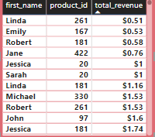

**SQL Query:**

**O. Join with Aggregation:**

SELECT

cp.customer_id,

cp.first_name, -- Assuming there's a column for the customer name in customer_profile

pr.product_id,

pr.product_name, -- Assuming there's a column for the product name in products

SUM(pr.price_per_unit * pu.quantity) AS total_revenue

FROM

customer_profile cp

JOIN

purchases pu ON cp.customer_id = pu.customer_id -- Join customer_profile with purchases

JOIN

products pr ON pu.product_id = pr.product_id -- Join purchases with products

GROUP BY

cp.customer_id,

cp.first_name, -- Include customer name if needed in the result

pr.product_id,

pr.product_name -- Include product name if needed in the result

ORDER BY

cp.customer_id,

pr.product_id;

**P. Customer Retention**

**Findings:**

* Analyzing repeat customers is essential for understanding customer loyalty and measuring retention.

**Insights:**

* Understanding customer retention helps businesses focus on improving loyalty programs and reducing churn.

**Recommendations:**

* Focus on repeat customers by identifying high-value segments and implementing loyalty programs or targeted marketing strategies.

**Visualization:**

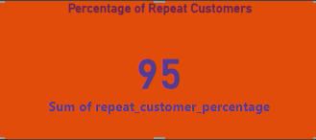

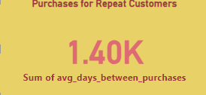

**SQL Query:**

**P1. Customer Retention:**

WITH customer_purchase_count AS (

SELECT

customer_id,

COUNT(DISTINCT purchase_id) AS purchase_count

FROM

purchases

GROUP BY

customer_id

)

SELECT

(COUNT(CASE WHEN purchase_count > 1 THEN 1 END) * 100.0) / COUNT(*) AS repeat_customer_percentage

FROM

customer_purchase_count;

**P2. Customer Retention:**

WITH customer_purchase_dates AS (

SELECT

customer_id,

MIN(purchase_date) AS first_purchase,

MAX(purchase_date) AS last_purchase,

DATEDIFF(MAX(purchase_date), MIN(purchase_date)) AS days_between_purchases

FROM

purchases

GROUP BY

customer_id

HAVING COUNT(DISTINCT purchase_id) > 1

)

SELECT

AVG(days_between_purchases) AS avg_days_between_purchases

FROM

customer_purchase_dates;

**Q. Time Series Analysis**

**Findings:**

* Time series analysis helps in forecasting trends, such as identifying seasonal variations in sales or customer purchases.

**Insights:**

* Time series analysis allows businesses to predict demand and plan inventory or marketing efforts effectively.

**Recommendations:**

* Use time series analysis for forecasting sales trends, marketing campaign performance, and demand fluctuations.

**Visualization:**

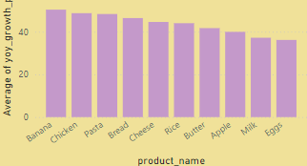

**SQL Query:**

**Q. Time Series Analysis:**

WITH product_purchase_year AS (

SELECT

p.product_id,

p.product_name,

EXTRACT(YEAR FROM pu.purchase_date) AS purchase_year,

COUNT(*) AS purchase_count

FROM

purchases pu

JOIN

products p ON pu.product_id = p.product_id

GROUP BY

p.product_id, p.product_name, EXTRACT(YEAR FROM pu.purchase_date)

),

yearly_growth AS (

SELECT

current.product_id,

current.product_name,

current.purchase_year,

current.purchase_count,

COALESCE(

((current.purchase_count - previous.purchase_count) / previous.purchase_count) * 100,

0

) AS yoy_growth_percentage

FROM

product_purchase_year current

LEFT JOIN

product_purchase_year previous

ON

current.product_id = previous.product_id

AND current.purchase_year = previous.purchase_year + 1

)

SELECT

product_id,

product_name,

purchase_year,

purchase_count,

yoy_growth_percentage

FROM

yearly_growth

ORDER BY

yoy_growth_percentage DESC;

**R. Subqueries**

**Findings:**

* Subqueries help retrieve data based on specific conditions or filters that cannot be achieved directly in a single query.

**Insights:**

* Subqueries can be powerful for advanced filtering and aggregation when dealing with complex data conditions.

**Recommendations:**

* Use subqueries for scenarios where multiple filtering or aggregation layers are needed.

**Visualization:**

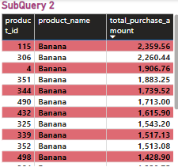

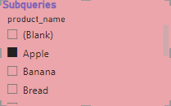

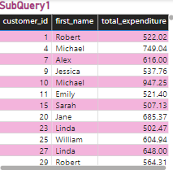

**SQL Query:**

**R1. Subqueries:**

SELECT

c.customer_id,

c.first_name,

SUM(p.price_per_unit * pu.quantity) AS total_expenditure

FROM

customer_profile c

JOIN

purchases pu ON c.customer_id = pu.customer_id

JOIN

products p ON pu.product_id = p.product_id

GROUP BY

c.customer_id, c.first_name

HAVING

SUM(p.price_per_unit * pu.quantity) > (

SELECT AVG(total_expenditure)

FROM (

SELECT SUM(p.price_per_unit * pu.quantity) AS total_expenditure

FROM purchases pu

JOIN products p ON pu.product_id = p.product_id

GROUP BY pu.customer_id

) AS customer_expenditures

);

**R2. Subqueries**

SELECT

pr.product_id,

pr.product_name,

SUM(pr.price_per_unit * pu.quantity) AS total_purchase_amount

FROM

products pr

JOIN

purchases pu ON pr.product_id = pu.product_id

GROUP BY

pr.product_id, pr.product_name

HAVING

SUM(pr.price_per_unit * pu.quantity) > (

SELECT AVG(total_purchase_amount)

FROM (

SELECT SUM(pr.price_per_unit * pu.quantity) AS total_purchase_amount

FROM purchases pu

JOIN products pr ON pu.product_id = pr.product_id

GROUP BY pu.product_id

) AS product_purchase_amounts

);

**S. Correlated Subqueries**

**Findings:**

* Correlated subqueries allow comparison between rows in the outer query and inner subqueries.

**Insights:**

* This type of query is valuable for comparisons across different data subsets, such as identifying customers who purchase above their average spend.

**Recommendations:**

* Use correlated subqueries for advanced filtering and comparison between related rows of data.

**Visualization:**

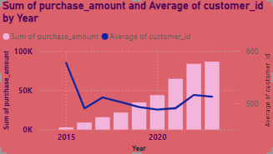

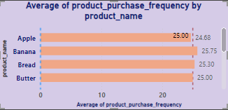

**SQL Query:**

**S1. Correlated Subqueries:**

WITH customer_avg_purchase AS (

SELECT

pu.customer_id,

AVG(pr.price_per_unit * pu.quantity) AS avg_purchase_amount

FROM

purchases pu

JOIN

products pr ON pu.product_id = pr.product_id

GROUP BY

pu.customer_id

)

SELECT

pu.customer_id,

pu.purchase_date,

SUM(pr.price_per_unit * pu.quantity) AS purchase_amount

FROM

purchases pu

JOIN

products pr ON pu.product_id = pr.product_id

GROUP BY

pu.customer_id, pu.purchase_date

HAVING

SUM(pr.price_per_unit * pu.quantity) > (

SELECT

avg_purchase_amount

FROM

customer_avg_purchase cap

WHERE

cap.customer_id = pu.customer_id

);

**S2. Correlated Subqueries:**

SELECT

pr.product_id,

pr.product_name,

COUNT(pu.purchase_id) AS product_purchase_frequency

FROM

products pr

JOIN

purchases pu ON pr.product_id = pu.product_id

GROUP BY

pr.product_id, pr.product_name

HAVING

COUNT(pu.purchase_id) > (

SELECT

AVG(product_frequency)

FROM (

SELECT

p2.product_id,

COUNT(pu2.purchase_id) AS product_frequency

FROM

products p2

JOIN

purchases pu2 ON p2.product_id = pu2.product_id

GROUP BY

p2.product_id

) AS overall_avg_frequency

);

**T. Date Functions**

**Findings:**

* Date functions help extract and manipulate date-related information, enabling time-based analysis.

**Insights:**

* This allows businesses to segment or aggregate data by year, month, or even day, providing insights into trends over time.

**Recommendations:**

* Use date functions to analyze trends over time, especially when performing time-series analysis or grouping data by date.

**Visualization:**

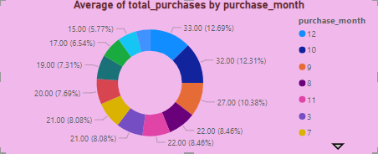

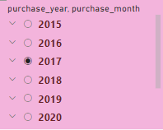

**SQL Query:**

**T. Date Functions:**

SELECT

YEAR(p.purchase_date) AS purchase_year,

MONTH(p.purchase_date) AS purchase_month,

COUNT(p.purchase_id) AS total_purchases

FROM

purchases p

GROUP BY

YEAR(p.purchase_date), MONTH(p.purchase_date)

ORDER BY

purchase_year, purchase_month;

**U. Visualization in Power BI**

**Findings:**

* Power BI offers powerful visualizations like bar charts, line graphs, pie charts, and heat maps for analyzing and presenting data.

**Insights:**

* Visualizations help to transform complex data into actionable insights for decision-makers.

**Recommendations:**

* Utilize Power BI’s visual capabilities to create interactive dashboards that present key business metrics clearly and effectively.

**Visualization:**

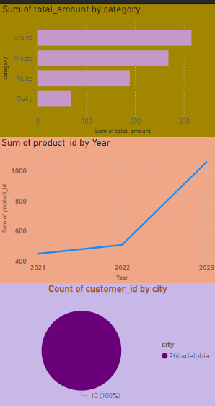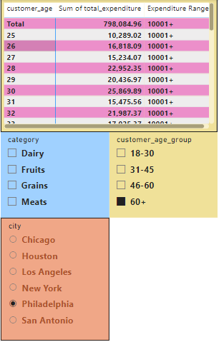

**SQL Query:**

**U. Visualization in Power BI:**

SELECT

c.customer_id,

c.first_name,

c.last_name,

c.date_of_birth,

p.product_id,

p.product_name,

p.category,

pur.purchase_date,

pur.total_amount,

c.city,

-- Calculate customer age from date_of_birth

TIMESTAMPDIFF(YEAR, c.date_of_birth, CURDATE()) AS customer_age,

-- Age Group categorization based on customer age

CASE

WHEN TIMESTAMPDIFF(YEAR, c.date_of_birth, CURDATE()) <= 18 THEN 'Under 18'

WHEN TIMESTAMPDIFF(YEAR, c.date_of_birth, CURDATE()) BETWEEN 19 AND 30 THEN '18-30'

WHEN TIMESTAMPDIFF(YEAR, c.date_of_birth, CURDATE()) BETWEEN 31 AND 45 THEN '31-45'

WHEN TIMESTAMPDIFF(YEAR, c.date_of_birth, CURDATE()) BETWEEN 46 AND 60 THEN '46-60'

ELSE '60+'

END AS customer_age_group

FROM

customer_profile c

JOIN

purchases pur ON c.customer_id = pur.customer_id

JOIN

products p ON pur.product_id = p.product_id

WHERE

pur.purchase_date IS NOT NULL;

**V. Advanced Visuals**

**Findings:**

* Power BI supports advanced visuals such as scatter plots, heat maps, and trend lines to uncover patterns and relationships in data.

**Insights:**

* These visuals provide deeper insights and allow businesses to track correlations, trends, and patterns across datasets.

**Recommendations:**

* Implement advanced visuals to help in predictive analysis, customer segmentation, and performance tracking.

**Visualization:**

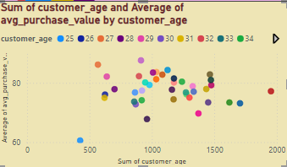

**SQL Query:**

**V. Advanced Visuals:**

SELECT

c.customer_id,

FLOOR(DATEDIFF(CURDATE(), c.date_of_birth) / 365) AS customer_age,

AVG(p.total_amount) AS avg_purchase_value

FROM

customer_profile c

JOIN

purchases p ON c.customer_id = p.customer_id

GROUP BY

c.customer_id, customer_age

ORDER BY

customer_age;

**W. Power BI Dashboard**

**Findings:**

* Combining multiple visualizations into a Power BI dashboard helps summarize key performance indicators (KPIs) for quick decision-making.

**Insights:**

* Dashboards provide a snapshot of business performance, making it easy to monitor KPIs and make timely decisions.

**Recommendations:**

* Design a dashboard that includes KPIs like total revenue, customer performance, and product sales to offer insights at a glance.

**Visualization:**

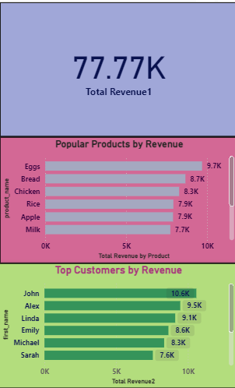

**SQL Query:**

**W. Power BI Dashboard:**

SELECT

p.product_id,

p.product_name,

p.category AS product_category,

c.customer_id,

c.first_name,

c.city AS customer_city,

FLOOR(DATEDIFF(CURRENT_DATE, c.date_of_birth) / 365) AS customer_age,

pu.purchase_date,

pu.total_amount,

pu.total_amount AS total_expenditure -- Alias for simplicity

FROM

customer_profile c

JOIN

purchases pu ON c.customer_id = pu.customer_id

JOIN

products p ON pu.product_id = p.product_id

ORDER BY

pu.purchase_date DESC;

**Overall Dashboard:**

